EXPERIMENT NO. 03

   **Aim:** To apply Data Manipulation Language (DML) to add and modify data in the university database

**Description:** DML is an abbreviation of Data Manipulation Language. The DML commands in Structured Query Language change the data present in the SQL database. We can easily access, store, modify, update and delete the existing records from the database using DML commands.

Some of the commands are :- Insert, Select, Update, Delete.

DML COMMANDS:-

1. Insert Command:- This is used to add one or more rows to a table. The values are separated by commas and the data types char and date are enclosed in apostrophes. The values must be entered in the same order as they are defined.

 Syntax:-  INSERT INTO table_name (column1, column2, column3, ...)VALUES (value1, value2, value3, ...);

OUTPUT:-

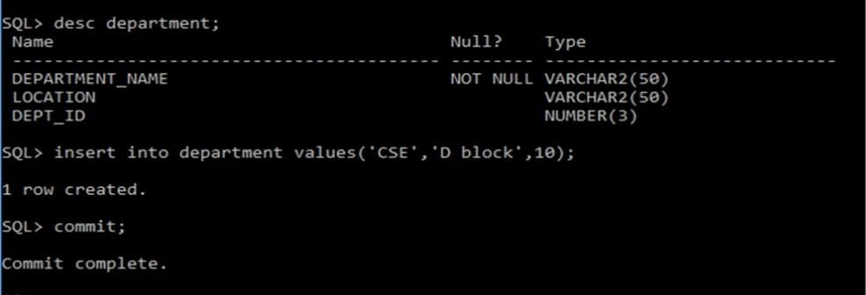

2. Select Command:- It is used to retrieve information from the table. It is generally referred to as querying the table. We can either display all columns in a table or only specify columns from the table.

Syntax:- SELECT column1, column2, ... FROM table_name;

OUTPUT:-

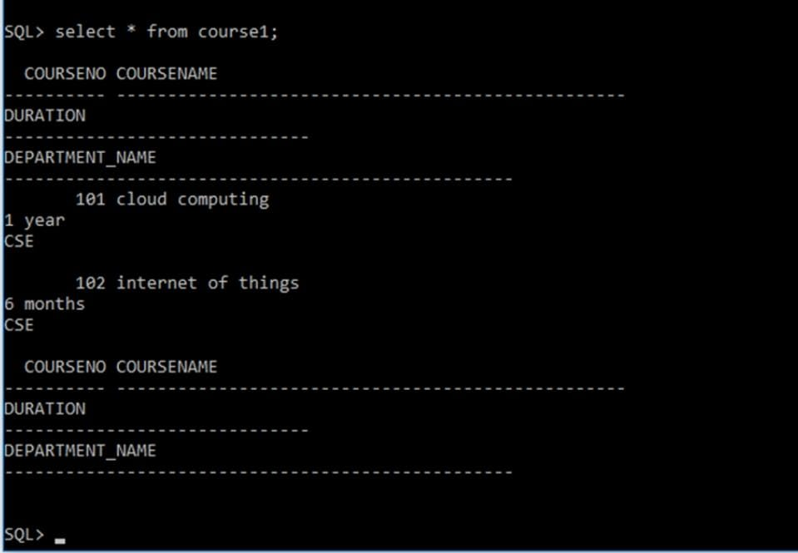

3.  Update Command: - It is used to alter the column values in a table. A single column may be updated or more than one column could be updated.

Syntax:-

UPDATE table_name SET column1 = value1, column2 = value2...., columnN = valueN WHERE [condition]

OUTPUT:-

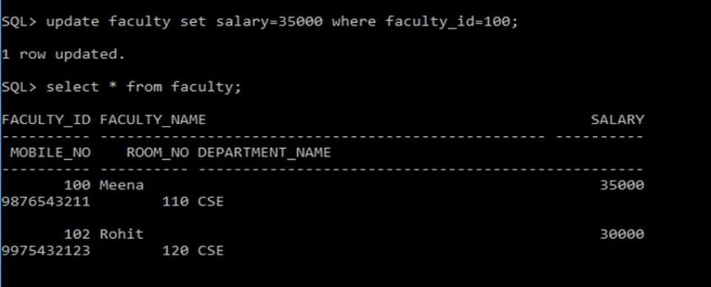

4.  Delete Command :- After inserting row in a table we can also delete it if required. The delete command consists of a from clause followed by an optional where clause.

  Syntax:- DELETE FROM table_name;

OUTPUT:-

